SAI RAM

Login Page

Change the Login Page as per below

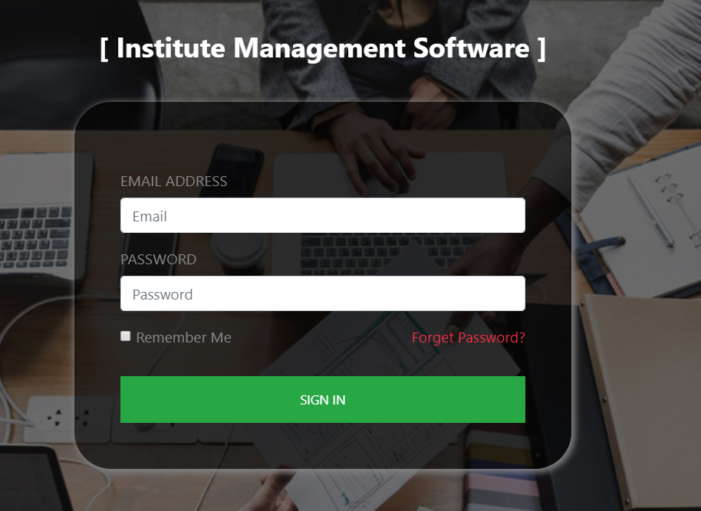

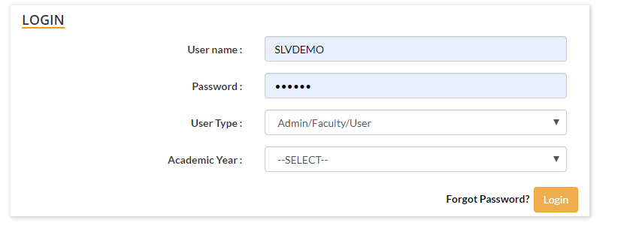

Add two more fields “User Type” and “Academic Year” then Forgot Password option.

User Type Shall contain below options

* Admin
* Account
* Stock
* Library
* System User

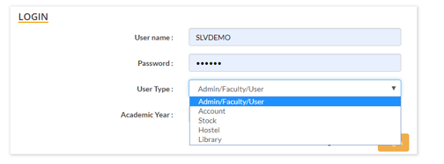

2. Roles and Responsibilities of each User.

|  |  |  |  |
| --- | --- | --- | --- |
| Sl No | User Type | Access Modules | Access Permission |
| 1 | Admin | All modules | Create/Edit/Delete/View |
| 2 | Account | Account Panel, Configuration -> Fees, Expense Type, Dashboard | Create/Edit/View |
| 3 | Stock | Stock Panel | Create/Edit/View |
| 4 | Library | Library Management | Create/Edit/View |
| 5 | System User | All modules | View |
|  |  |  |  |